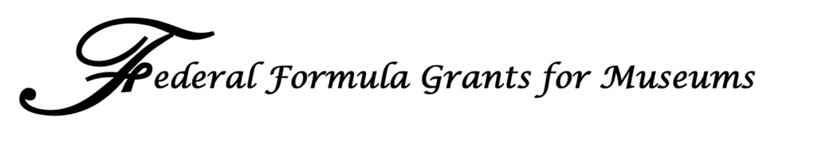

November, 2008

Representatives from the Federal Formula Grant Coalition, American Association of Museums, Association for Science and Technology Centers, Association of Art Museum Directors, and Association of Zoos and Aquariums have been meeting since July 2008 to negotiate a package to support growth of museum grant programs through the reauthorization of the Institute for Museum and Library Services (IMLS). The request outlined below is the result of that work, and will be presented by all organizations to Members of Congress for the 2009 reauthorization of IMLS.
- A base amount of $45 million per year for existing national programs, such as Museums for America and others.
- When IMLS’ budget for museum programs exceeds $45 million per year, up to $2 million per year will be appropriated for state needs assessments. These state needs assessments are the first step in the establishment of a federal formula grant program.
- New national programs, specifically grants for conservation and traveling exhibitions, as well as a fast-track process for small museums, will be funded when the base amount of $47 million is exceeded.
- For any amount in excess of $72 million per year, at the discretion of IMLS, up to $20 per year million may be allocated for federal formula grants to the states.
- State formula grants will only be funded in states that have (1) conducted a needs assessment and (2) provided to IMLS an acceptable five year plan on how the funds will be used.
- For any amount in excess of $92 million per year, 50% will be allocated to state programs and 50% for growth of national programs.
- An assessment of the formula grant program will be conducted after it has been in existence for two years at a funding level of at least $10 million to evaluate the program. The two-year time period and funding level does not include state assessments.
The need for growth in national programs was taken into consideration as follows:
  - A 48% increase in existing national programs before any state or new national programs begin—from the current level of $30.445 million per year to $45 million.
  - A 130% increase in national programs, both existing and new programs, before a federal formula grant program will be initiated.
  - The past 10 years of growth for IMLS has averaged 3.4% per year. As articulated above, this package requires a significant effort to support unprecedented growth of national programs before state grants are authorized.
  - For any amounts in excess of $92 million per year, national and state programs are given equal priority.

